10/20/2025
UDAY KIRAN SIRIGIRI

Classic Visuals Dashboard

Part 1: Data Selection & Analysis (30 points)
1.1 Dataset Selection
The dataset chosen for this project is the Retail Supply Chain Sales Dataset from Kaggle. This topic was selected due to a strong interest in business logistics and its direct relevance to a career as a supply chain analyst. The dataset is ideal as it contains comprehensive sales, product, and logistics information, enabling a full examination of the supply chain from order placement to final shipment. It provides an opportunity to analyse the efficiency of different shipping methods, explore regional sales and profit, and understand the operational impact of various product categories.

- Source: https://www.kaggle.com/datasets/shandeep777/retail-supply-chain-sales-dataset?utm_source=chatgpt.com

- Rows: 9,994 records

- Columns: 23 Fields

- Context: Transactional sales and fulfilment data for a retail business, covering customer orders, product details, and shipping logistics.

1.2 Variable Identification
Document all variables in your dataset

Variable Name | Variable Type | Business Meaning
Row ID | Categorical | A unique identifier for each row in the dataset.
Order ID | Categorical | A unique identifier for each customer order.
Order Date | Temporal | The date the customer placed the order.
Ship Date | Temporal | The date the order was shipped to the customer.
Ship Mode | Categorical | The method of shipping used (e.g., Standard Class, First Class).
Customer ID | Categorical | A unique identifier for each customer.
Customer Name | Categorical | The name of the customer.
Segment | Categorical | The customer segment (e.g., Consumer, Corporate, Home Office).
Country | Categorical | The country where the customer is located.
City | Categorical | The city where the customer is located.
State | Categorical | The state where the customer is located.
Postal Code | Categorical | The postal code of the customer's location.
Region | Categorical | The geographical region (e.g., East, West, Central).
Retail Salespeople | Categorical | The salesperson associated with the order.
Product ID | Categorical | A unique identifier for each product.
Category | Categorical | The highest-level product category (e.g., Furniture, Technology).
Sub-Category | Categorical | The specific product sub-category (e.g., Chairs, Phones).
Product Name | Categorical | The name of the product.
Returned | Categorical | Indicates if the order was returned ('Yes' or 'No').
Sales | Numerical | The total revenue from the sale of a product.
Quantity | Numerical | The number of units of a product sold.
Discount | Numerical | The discount percentage applied to the sale.
Profit | Numerical | The profit earned from the sale.

1.3 Expected Insights & DAX Measures
Pre-Dashboard Planning:
What 3-5 insights do you expect to discover?
Based on dataset and my interest in supply chain analysis, here are 4 key insights i could aim to discover:
- Profitability Drivers: Which product Category and Sub-Category are the most and least profitable? This can help the business decide where to focus its sales efforts and inventory.
- Geographical Performance: Which State or Region generates the highest sales and profit? This is crucial for optimizing logistics, marketing spend, and supply chain resources.
- Sales Seasonality: How do sales trend over time? Can we identify specific months or quarters with peak sales, which would heavily influence inventory planning and staffing?
- Discount Strategy Effectiveness: What is the impact of Discounts on Sales volume and, more importantly, on Profit? Answering this can help refine the company's pricing and promotional strategies to maximize profitability.

DAX Measures & Academic Citations
Here are five essential DAX measures we will create to help uncover those insights, complete with the required APA citations explaining their importance.
1) Total Sales
DAX:
Total Sales =
SUM (‘Retails Order Full Dataset'[Sales])
Citation for Importance (APA Format):
Microsoft. (2024). DIVIDE function (DAX) & aggregation basics. Microsoft Learn. (official DAX reference for core aggregations) Microsoft Learn

2) Profit Margin %
DAX:
Profit Margin % =
VAR Sales_ = SUM (‘Retails Order Full Dataset'[Sales])
VAR Profit_ = SUM (‘Retails Order Full Dataset'[Profit])
RETURN
DIVIDE (Profit_, Sales_)

Citation for Importance (APA Format): Farris, P. W., Bendle, N. T., Pfeifer, P. E., & Reibstein, D. J. (2010). Marketing metrics: The definitive guide to measuring marketing performance. Pearson. (establishes profit margin as a core profitability KPI)
Note: We use DIVIDE instead of / to safely handle divide-by-zero. Microsoft recommends this best practice. Microsoft Learn

3) YoY Sales Growth %
DAX
YoY Sales Growth % =
VAR SalesCY = [Total Sales] VAR SalesPY =CALCULATE (
[Total Sales], SAMEPERIODLASTYEAR ( 'Calendar Table'[Date] )
)
RETURN
DIVIDE ( SalesCY - SalesPY, SalesPY )

Citation for Importance (APA Format):
Microsoft. (2025). SAMEPERIODLASTYEAR (DAX). Microsoft Learn. (official YoY function for time-intelligence) Microsoft Learn
Investopedia. (n.d.). Year-over-year (YOY): What it means and how it’s used. (YoY comparisons mitigate seasonality) Investopedia

4) Avg Shipping Time (days)
DAX (order ship, per row average):
Avg Shipping Days =
AVERAGEX (
'Retails Order Full Dataset',DATEDIFF ('Retails Order Full Dataset'[Order Date],
'Retails Order Full Dataset'[Ship Date],
DAY))
Citation for Importance (APA Format): Thomasnet. (2022). Order cycle time: Definition, formula, and improvement. (order cycle/fulfillment time is a key supply-chain KPI tied to customer experience)

5) 30-Day Moving Average of Sales
DAX Formula:
30-Day Moving Average =
CALCULATE (AVERAGEX ('Retails Order Full Dataset', 'Retails Order Full Dataset'[Sales]),
DATESINPERIOD (‘Calendar Table'[Date], LASTDATE ('Calendar Table'[Date]),
-30, DAY))

Citation for Importance (APA Format):
Trugman, G. (2022). Data Analysis with Power BI. Packt Publishing.
Trugman explains that moving averages are an essential time-series technique to reduce noise and reveal longer-term sales patterns that raw daily numbers can obscure.

Part 2: Dashboard Construction
Step 1: KPI Cards
To show the most important business metrics quickly, four KPI cards were arranged in a single row across the top of the dashboard:
Total Sales: Compiles all the money made from all the orders. ($2M)
Profit Margin %: Indicates how profitable the company is overall. The value is conditionally formatted so that it is red for negative margins, yellow for low margins, and green for good margins. (12.5%)
YoY Sales Growth %: Displays the annual percentage change in sales. When growth is positive, the value dynamically shifts to green; when growth is negative, it changes to red.
Average Shipping Time (Days): This crucial operational metric indicates the typical number of days needed to complete an order. If the time exceeds the company's target, it is conditionally formatted to turn red. (35 is maximum)
Step 2: Dashboard Grid
A clean and balanced 2x2 grid was implemented below the main KPI cards to organize the detailed visualizations, following the best practices outlined in the course material.
- Top Row: A Bar chart for ranking (Profit by Product Sub-Category) and a donut chart for structure (Sales by Customer Segment).
- Bottom Row: A line chart for dynamics (Monthly Sales Trend) and a matrix for detailed overview (Product Performance Details).
Gridlines and “Snap to Grid” were enabled for precise alignment and equal spacing. Each visual was proportionally sized to maintain a left-to-right flow from overall patterns to detailed breakdowns.
Step 3: Adjust Page BackgroundTo create a polished and contemporary look, a solid, green colour (#4F9446) was chosen for the page background. This strategy was chosen to guarantee high contrast and create a strong visual hierarchy.
The light-coloured chart containers stand out against the dark background, directing the user's attention straight to the data visualizations. This design decision keeps all text and numbers extremely readable, resulting in a dashboard that is clear, unified, and simple to use.
Visual and Page Backgrounds:
Wallpaper: To add a subtle, thematic texture to the entire report page, a 4K global logistics image was applied to the wallpaper with 80% transparency.
Canvas background: To create a gentle colour wash effect, a solid lilac colour (#DBC3D6) was applied on top of the wallpaper with 80 % transparency.
Visual background: Solid slate blue fill (#707A9E) with 10% transparency is used in all charts and KPI containers. This produces a crisp "floating" effect that makes the images readable while still letting the background layers show through them slightly.
Step 4: Customize the Colour Theme
To produce a polished and eye-catching dashboard, I created a unique "Executive Command" theme. For optimal readability and clarity, a colour scheme with vivid blues and a contrasting orange accent was selected. To create a contemporary look, a complex, multi-layered background was used.By using a consistent, high-contrast colour scheme and limiting the use of red and green to positive/negative conditional formatting indicators.
Using an external generator, I produced and saved the theme as a JSON file, which I then imported into the Power BI report.

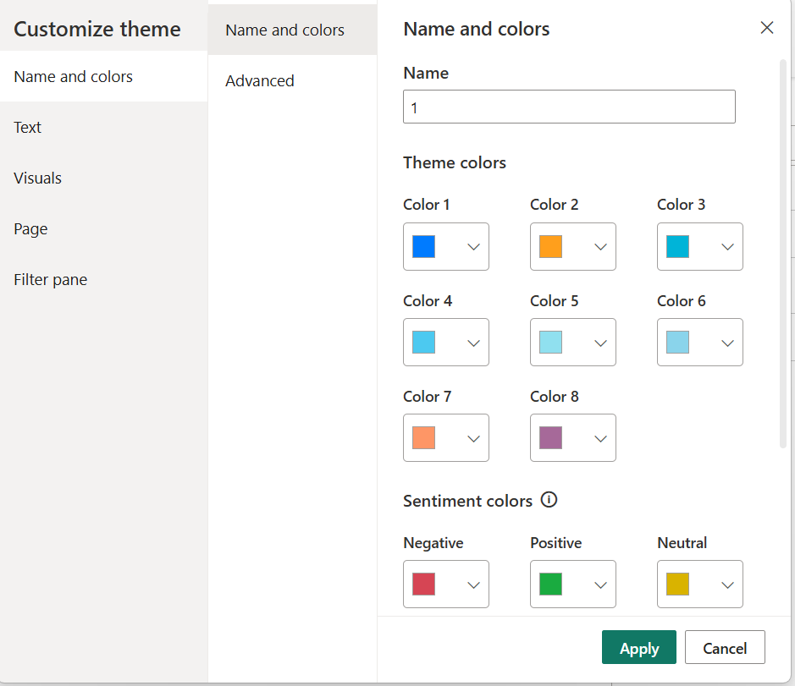

Step 5: Check Cross-Filtering

Interaction Logic: As mandated by the project instructions, all visual interactions were manually set to "Filter" rather than the default "Highlight" setting to enhance the dashboard's analytical capabilities and user experience. I made sure that clicking on a data point in any visual (such as a bar, donut slice, or matrix row) immediately filters every other visual on the page by using Power BI's "Edit Interactions" feature. Users can delve deeper into the data and uncover insights more easily and effectively with this logic.
Cross-filtering paths were set up and tested as follows:
- To filter the KPIs, donut chart, line chart, and matrix, choose a subcategory in the bar chart.
- By selecting a customer segment in the donut chart, all other dashboard visuals are filtered.
- KPIs and all other charts are filtered when a row for a category or subcategory in the matrix is clicked.
- The dashboard is filtered by using the "Year" or "Region" slicers at the top of the report.
To make sure all visuals were updated consistently, accurately, and dynamically, I tested each of these filter paths.

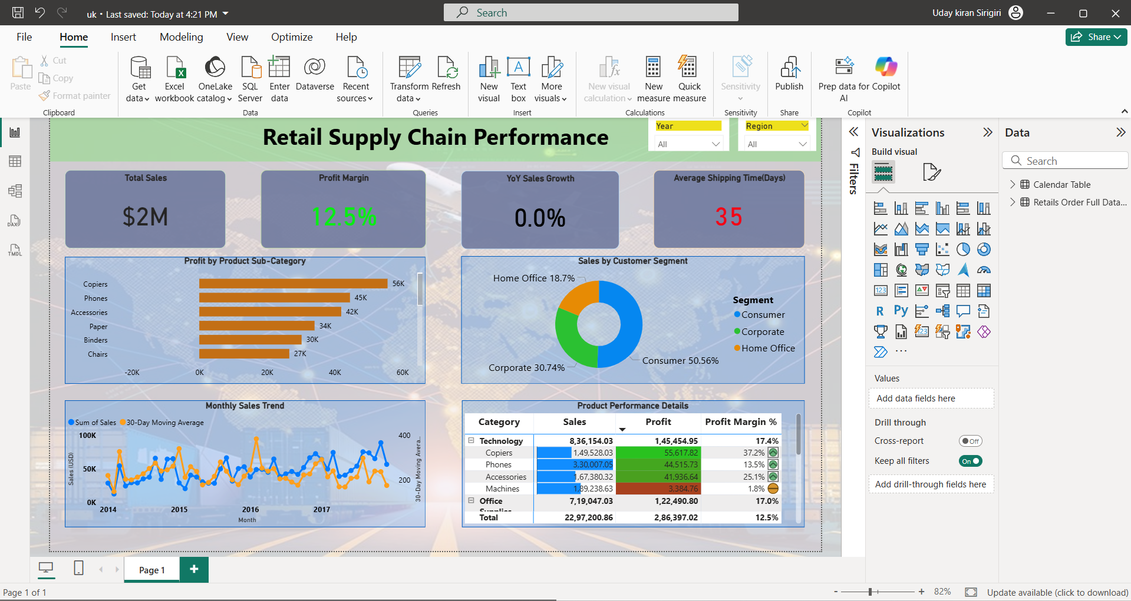
Final Dashboard:

Part 3: Business Value & Insights
3.1 Dashboard Pitch

- How would you "sell" this dashboard to stakeholders?
The dashboard I developed functions as a business health monitoring system which extends beyond traditional reporting functions. The dashboard exists to replace our time-consuming process of searching through complex spreadsheets. The dashboard presents all essential business metrics through a single clean interface which automatically updates its data. The system allows users to interact with it through complete interactivity. The system enables users to transition from viewing national data to identifying product-specific issues in particular cities through a single mouse click. The system functions to reduce our work hours while enabling us to generate better choices at increased speed. The system transforms complex business inquiries into simple solutions which enable us to identify profitable areas and operational improvement opportunities within seconds.

- What business problems does it solve?
My business dashboard addresses three major operational issues through its functionality. The system identifies products which generate profits under the appearance of profitability. The dashboard reveals product profitability through a simple color-coded system which displays red for losses and green for profits in the KPI Cards. The dashboard system identifies shipping delays through its "Average Shipping Time"(Days) metric which functions as an alert system. The system alerts us to investigate delivery delays when shipping time exceeds our target of 4 days because it displays red indicators. Users can identify the source of delivery problems by selecting specific shipping areas or methods from the dashboard. The system enables us to determine optimal warehouse stock levels by displaying sales patterns through visual charts. The sales trend chart provides clear visibility of our peak business periods. The moving average line in the system helps us identify actual sales patterns by reducing daily fluctuations so we can purchase stock during optimal times and maintain sufficient inventory of popular items.

- Who is the target audience?
The dashboard exists for two main user groups which include Sales Managers and warehouse operation staff. The dashboard provides instant product performance data when Sales Managers select their West region. The dashboard reveals profitable products and their buyers to Sales Managers who can use this information to direct their sales teams. Warehouse Managers use the dashboard
daily to check if shipping operations exceed normal timeframes. The system enables Warehouse Managers to identify shipping delays by selecting specific shipping companies with a single mouse click. The system provides essential information to our highest-ranking executives. The dashboard displays essential business metrics through prominent numbers which enable executives to monitor company performance without needing extensive reports. The system allows Product Managers to track customer preferences for products while identifying which items require improvement.

3.2 Extracted Insights

Insight | Source | Importance | Action
1. "Copiers" and "Phones" are by far the company's main sources of revenue. | The bar chart labelled "Profit by Product Sub-Category." It is obvious that "Copiers" and "Phones" are the top two performers because their bars are noticeably longer than those of any other song. | This lets us know precisely which of our products are the best. We must concentrate our resources and sales efforts on these products to expand the company and increase profitability. | Make sure "Phones" and "Copiers" are always available. Make them a focal point of advertising campaigns and teach the sales force to upsell associated accessories with each purchase.
2. In actuality, regular "Consumer" customers account for more than half of our sales. | The "Sales by Customer Segment" Donut Chart. The "Consumer" slice is the largest section, making up 50.56% of the total sales. | This identifies our target audience. We can concentrate our marketing and sales efforts on the group that generates the most revenue rather than attempting to please everyone equally. | Provide a loyalty program or offer exclusive discounts to our "Consumer" clients directly to express gratitude for their patronage and to entice them to return.
3. The company's "busy season" is robust and predictable, with sales always reaching their highest point in the fourth quarter (Q4) of the year. | The Line Chart for "Monthly Sales Trend" All four years exhibit a consistent seasonal pattern, with the sales line peaking in the last few months of the year, from September to December. | This is a crucial planning insight. The business can proactively manage staffing, marketing, and inventory to optimize revenue and prevent stock outs of popular items because it knows our busiest season is approaching. | By the end of Q3 (September), start raising the amount of inventory for best-selling items. Make sure warehouses are adequately staffed to manage the spike in order volume from November through December and start holiday marketing campaigns in October.
4. With more profit than any other category, the "Technology" category serves as the company's main source of income. | The matrix of "Product Performance Details." When the "Total" rows are directly compared, the Technology category's profit of $1,45,454.95 is substantially greater than the Office Supplies category's profit of $1,22,490.80. | This strategic insight is crucial. We learn to concentrate our efforts and resources on what generates the highest revenue rather than just what sells the most. A company can become more intelligent and successful by basing decisions on profit rather than just sales. | A portion of the marketing budget should be diverted from general promotions to campaigns that target the lucrative "Technology" category. To entice customers to purchase more of these lucrative items together, we could also develop a "Home Office Tech Bundle."
5. The average shipping time for the company is extremely slow; it takes more than a month to complete customer orders. | The "Average Shipping Time (Days)" KPI card at the top of the dashboard. It prominently displays the high average of 35 days. | This is a serious warning sign for client satisfaction. Our reputation and long-term sales are harmed by our uncompetitive 35-day shipping time, which can also result in cancelled orders, bad reviews, and customers refusing to shop with us again. | Review the entire fulfilment process operationally right away. To determine whether "Standard Class" is the primary reason for the delays, use the "Ship Mode" slicer on the dashboard. Next, identify the precise regions or distribution hubs that are the source of the bottleneck using the Region slicer and the matrix.

